**Intelligent Customer Help Desk With Smart Document Understanding**

**Abstract:**

The typical customer care chatbot will answer straightforward queries, like store locations and hours, directions, and perhaps even creating appointments. once a matter falls outside of the scope of the pre-determined question set, the choice is usually to inform the client the question isn’t valid or provide to talk to a true person. In this project, there'll be another choice. If the client question is concerning the operation of a tool, the appliance shall pass the question onto Watson Discovery Service, that has been pre-loaded with the device’s homeowners manual. So now, rather than “Would you prefer to talk to a client representative?” we are able to come back relevant sections of the homeowners manual to assist solve our customers’ issues. To take it a step any, the project shall use the good Document Understanding feature of Watson Discovery to coach it on what text within the homeowners manual is very important and what's not. this can improve the answers came from the queries. Using SDU customer care chatbot is made which yielded answers with good accuracy and precision .

**Proposed Work**

**Setuping Environment**

Intially create a IBM cloud account. Go to Catlog and setup IBM watson, IBM Smart Disovery service and Node application

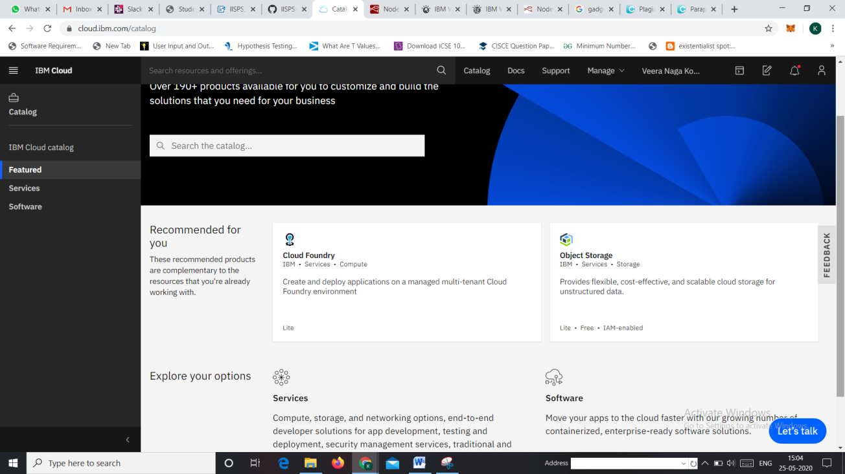

Figure catlog

**IBM Watson Discovery Service**

IBM Watson Discovery service is used for Smart Document Understanding. Smart Document Understanding (SDU) trains IBM Watson™ Discovery to extract custom fields in your documents. Customizing how your documents are indexed into Discovery improves the answers that your application returns. With SDU, you annotate fields within your documents to train custom conversion models. As you annotate, Watson is learning and starts to predict annotations. SDU models can be exported and used on other collections. After annoting the fields split data based on subtitles for smart document understanding.

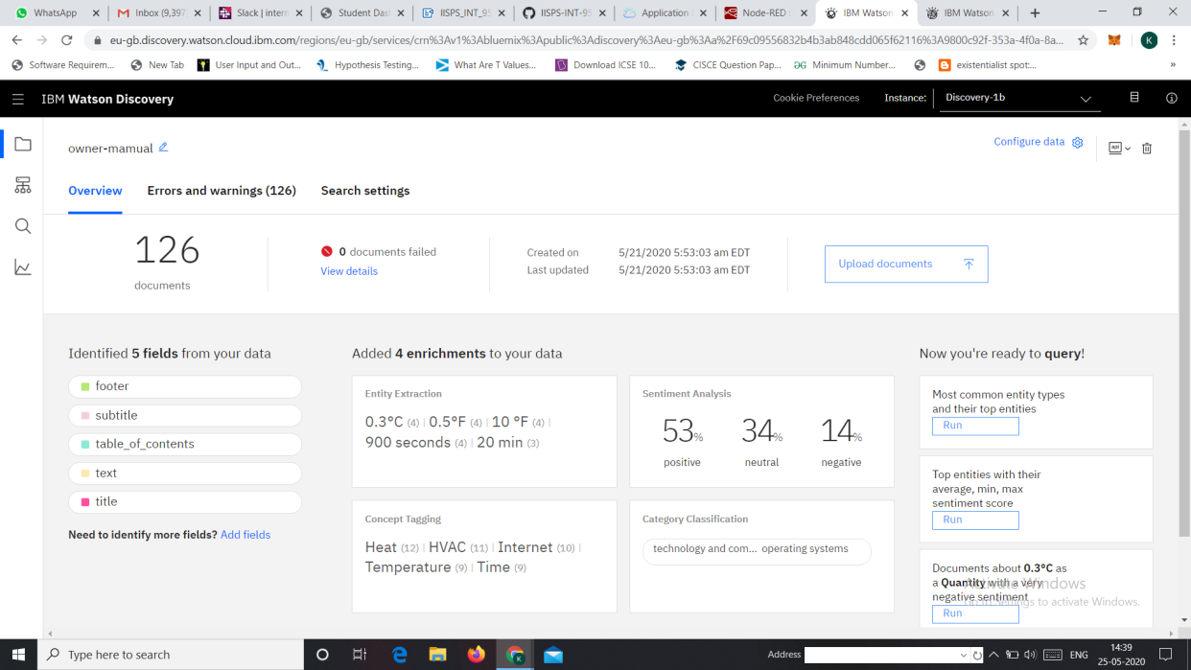

Figure Watson Discovery Service

**Setting Up Action**Action is nothing but a node.js code which is used by Watson assistant to contact Watson Discovery Serivce. Action acts as an interface between watson assistant and Discovery Service. We can setup action using functions in IBM cloud. Action takes few parameters such as URL, environmental_id, collection_id, API key. We should enable web interactions for action in the endpoint tab.

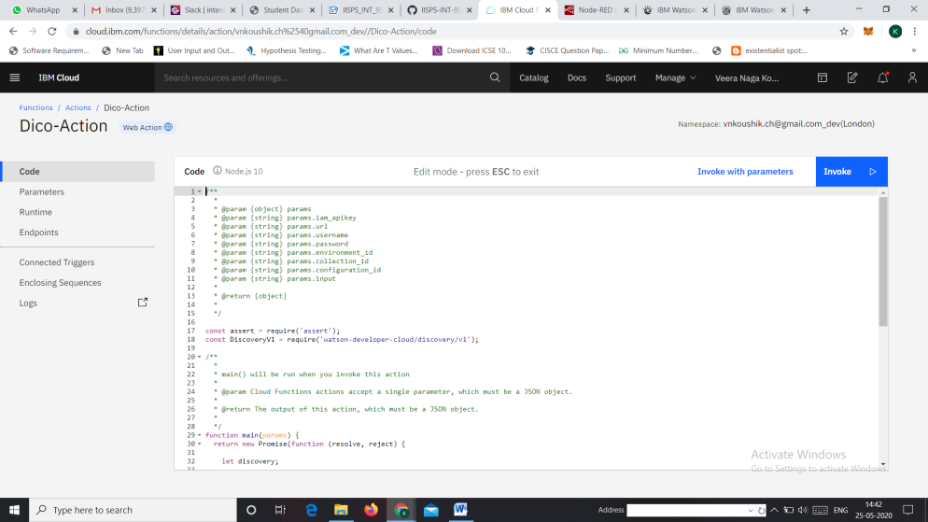

Figure Action Code

**Setting up IBM Watson Assistant** Watson Assistant is a conversation AI platform that helps you provide customers fast, straightforward and accurate answers to their questions, across any application, device or channel. By addressing common customer inquiries, Watson Assistant reduces the cost of customer interactions, helping your agents focus on complex use cases – not repetitive responses.

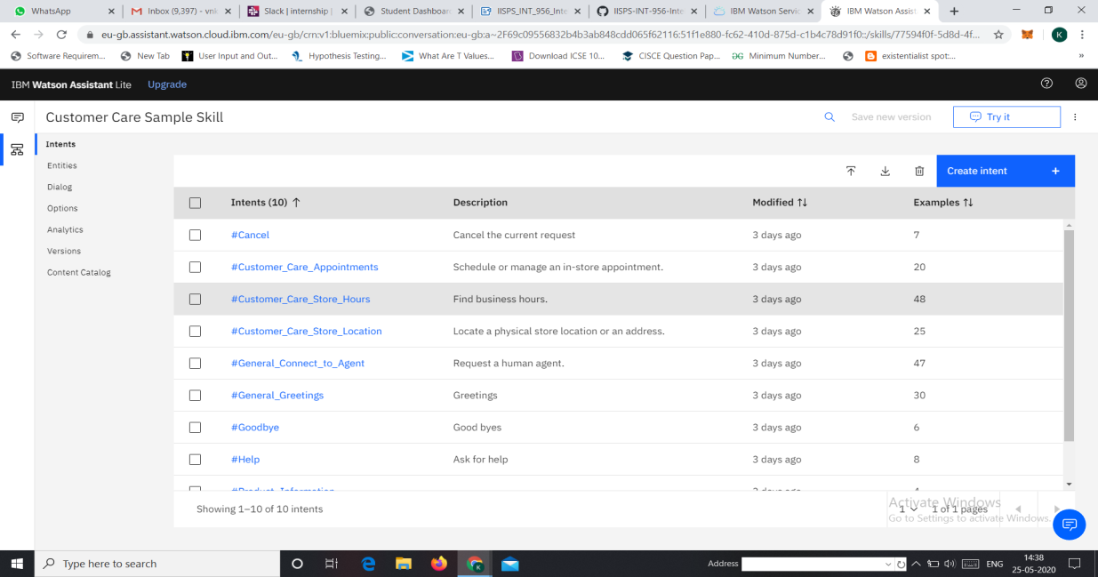

Figure Watson Assistant

**Node Red Platform**  Node Red is a programming that wires together all APIs and hardeware requirements for the project. Here node red is used for binding Watson Assistant and messages together.

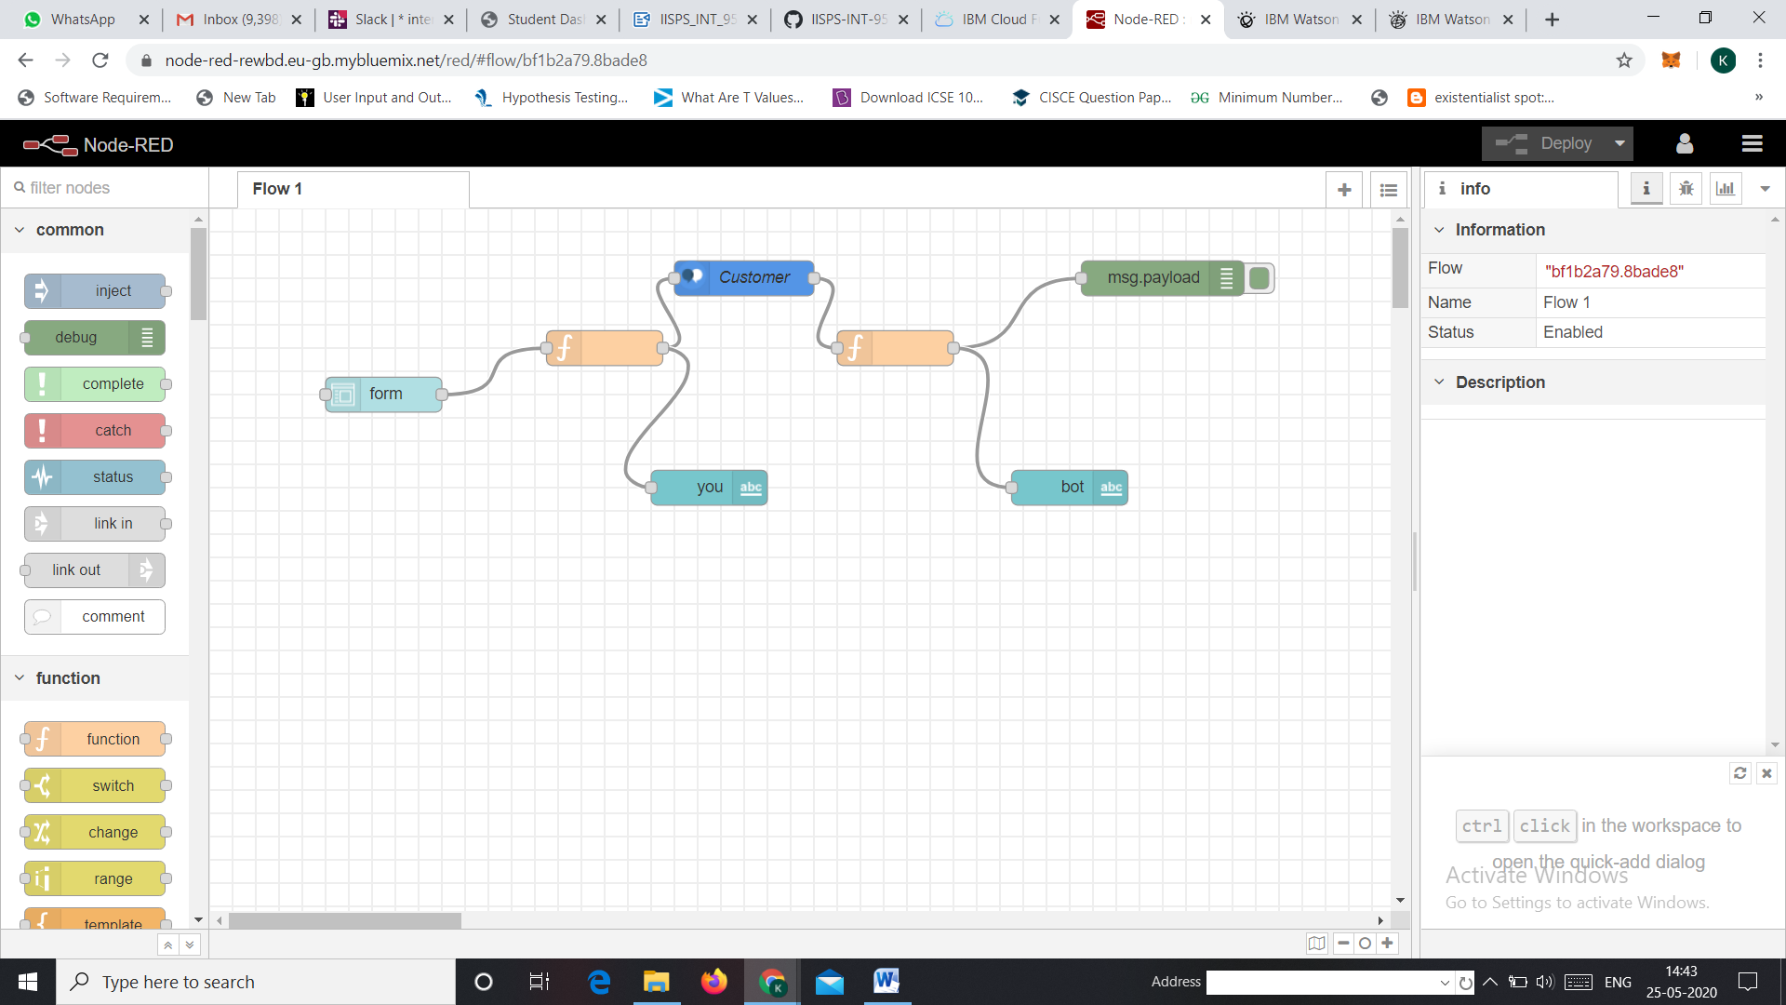

Figure Node Red Flow

Results of chatbot

Following are the results of the chatbot of various conversations.

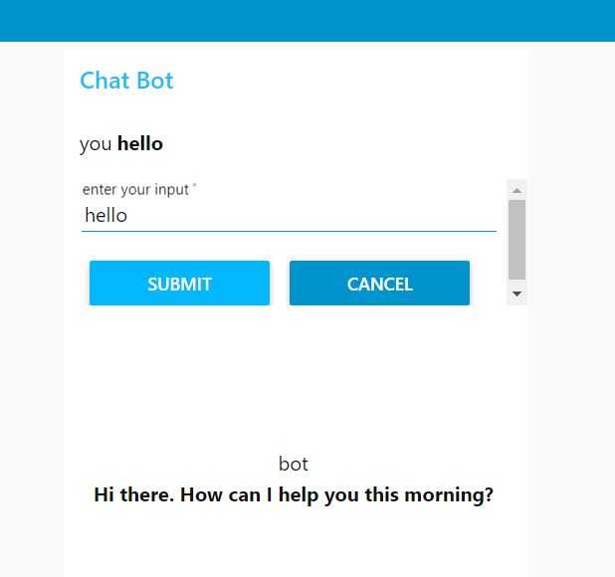

Figure Reply when message is hello

Above image consists of reply when the message is given as hello.

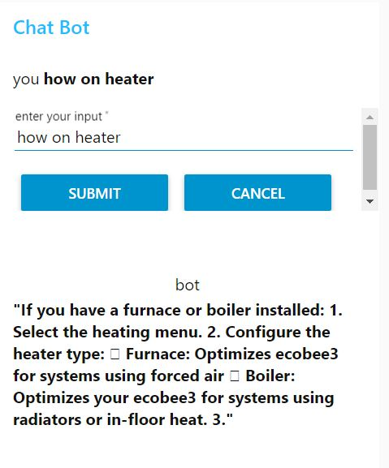

Figure Reply for heater question

Above image consists of reply when message is related to heater. This is possible due to usage of Smart documenting using Watson discovery service.

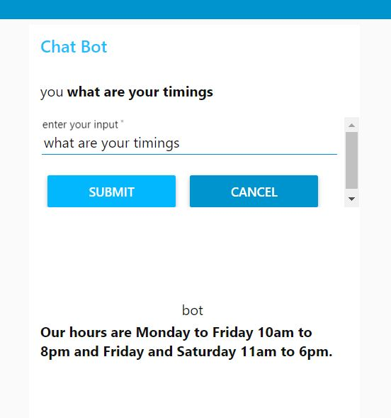

Figure Reply for timings

Figure 8 consists of reply when question is asked about timing. This is predefined intent comes with skill in Watson assistant service of IBM cloud.

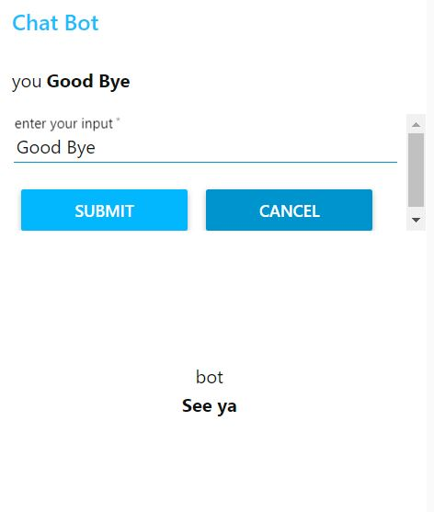

Figure Reply for good bye

Figure 9 consists of reply when messages related to send off are being typed.

**Conclusion and future work**

ChatBot worked efficiently when questions related to heater. Chatbot is giving good answers which great precision and accuracy. My future work corresponds to addition of few features such as giving answer to company specific gadgets. Use of text to speech service inorder make more interactive and acttractive.